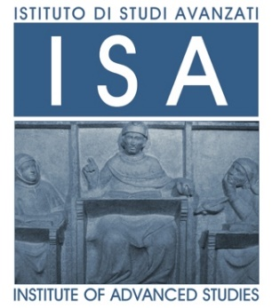

ISA Topic 2022-2023

Ocean Rights: for our Earth’s life

Bologna, Italy - Times are in CET
Round Table: Strategies, solutions and initiatives for Ocean Rights

Date, Hour: September 25, 2023, h. 5-7PM
Place: Institute of Advanced Studies, Sala Rossa, via Marsala 26, Bologna, Italy;
Teams link here
Oceans Rights | UN is strongly centering Oceans in the eye of the storm of the Earth’s and human’s life for this decade (2021-2030) with the impellent challenge i) to radically change our relationship with oceans ii) to achieve a sustainable and equitable ocean economy iii) for life on the planet to survive and thrive.  Within a multifaceted Ocean voyage, in which several UN initiatives (i.e The Ocean Decade 2021- 2030; The Ocean Race 2022-2023; the UN Ocean Conference 2022; the UN World Ocean Day 2022), events ( in which hundreds and thousands of marine scientists, economists, advocates, NGOs, policy-makers and governments focus problems, imagine solutions and promote collective actions to revitalize Oceans, we propose the “Ocean Rights: for our Earth’s life” UNIBO ISA Topic 2022-2023 to overall reflect and discuss on the new perspective of how Ocean Rights must be harmonized and integrated with other rights, such as Human Rights, Economic Rights etc., building up a Blue Justice to reconcile Humanities to Oceans.
Panellists | Daniela Addis, Founder and Director at Addis Law Firm "Environment&Sea"; Chairman of the professional association Generazione Mare  Ludovica Chiussi Curzi, Senior assistant professor of International Law @UniBO  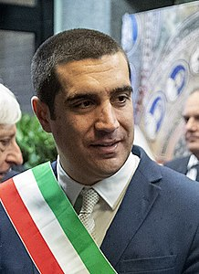  Michele De Pascale, Mayor of Ravenna, Italy  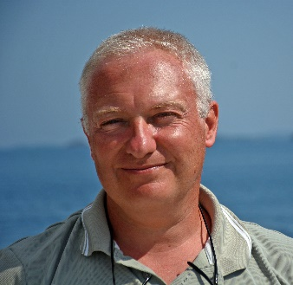  Massimo Ponti, Associate Professor of Ecology @UniBO  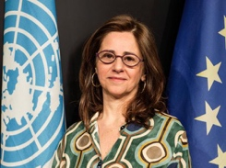  Francesca Santoro, Chair of the UNESCO Ocean Literacy Program, Ocean Decade; Venice  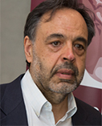  Anastasios Xepapadeas, Full Professor of Economics @UniBO and US National Academy of Sciences
Chairman | Alessia Cariani, Associate Professor of Zoology @UniBO
